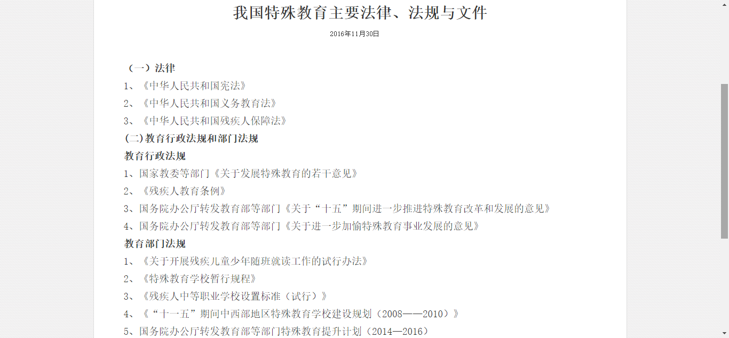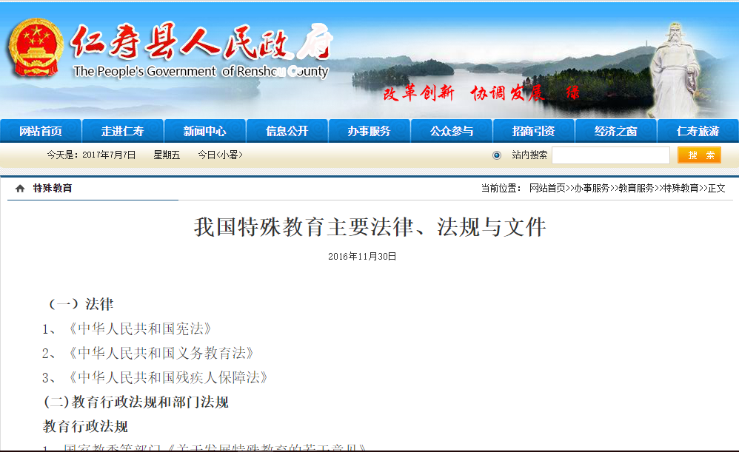

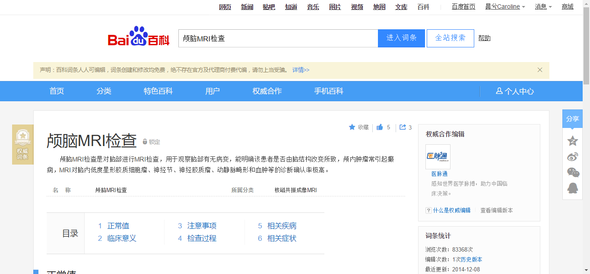

韦氏智力测量表

http://baike.baidu.com/link?url=2sy3gsFgcGHM7dJZjGsqFzF6DIQzjBue0m5nt1yAgit4am0PSAjbPIDKDbFmGER-acSexIX_hsxu6cWM2twoLCKcDEMckbvcbKvN4GPxFgsU263WwND3InB9BLqiZNtnFj-VNPFZkVHImdWCyJ8GoxiUa85V2W61CEgIHhx1oEe